Admin Log in

* Input Username and Password

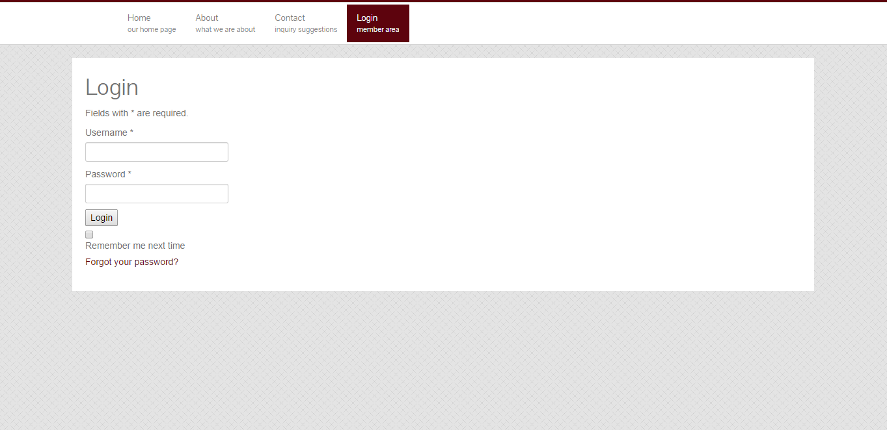

Change Password for admin

* Input Current Password
* Input New Password
* Repeat new password
* Click Save

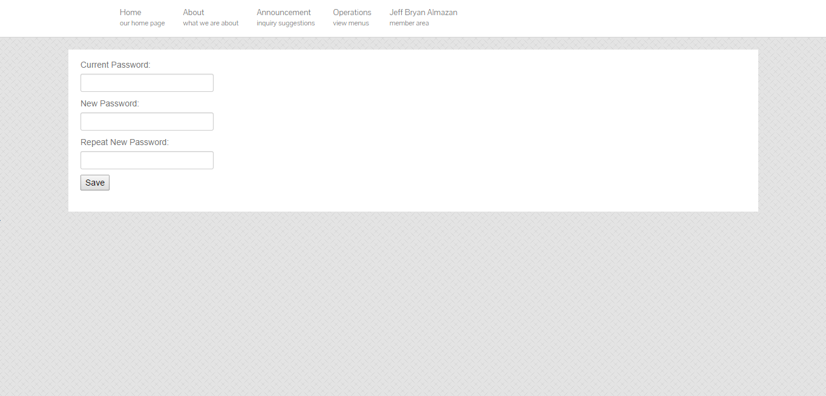

Update account settings for admin

* Click any of the information
* Click the check mark

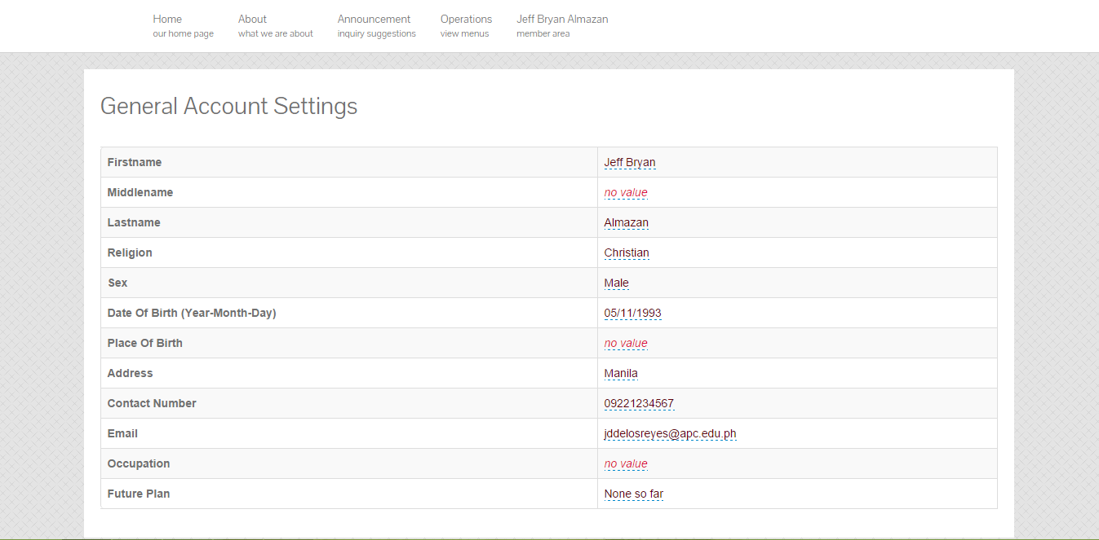

Create announcements

* Input Subject
* Input Announcement on Message Box
* Click Create

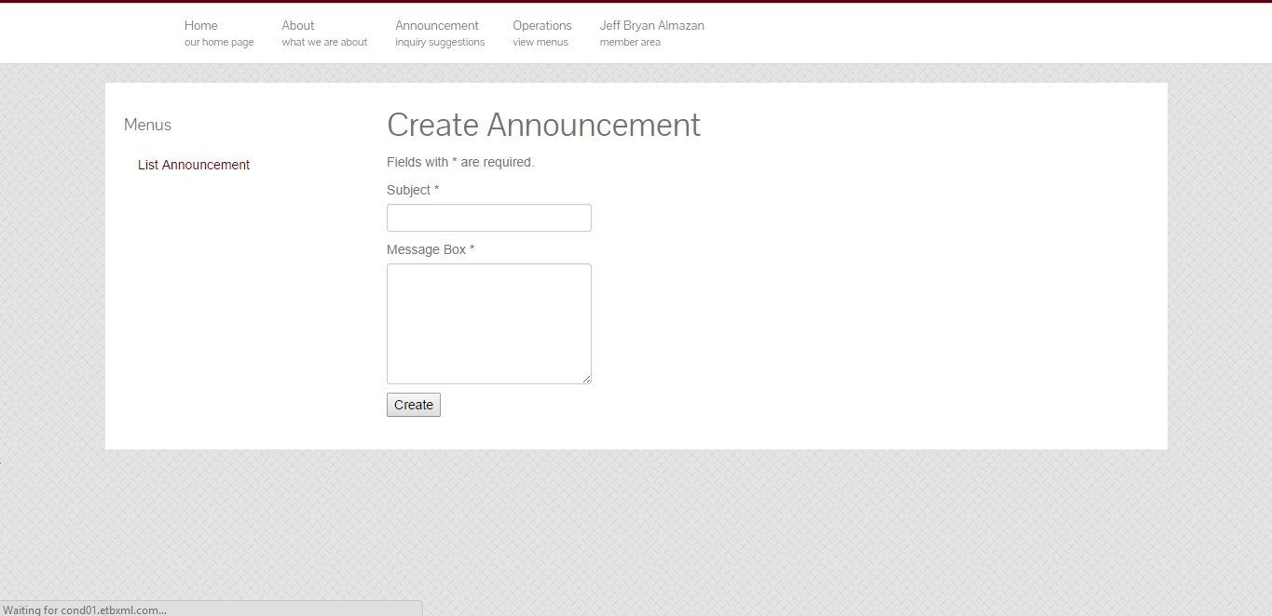

Create, Update and Delete for Announcements

Create

* To create announcements

List announcement

* To show all announcements
* To Edit announcements

Delete announcement

* Click to delete the announcement

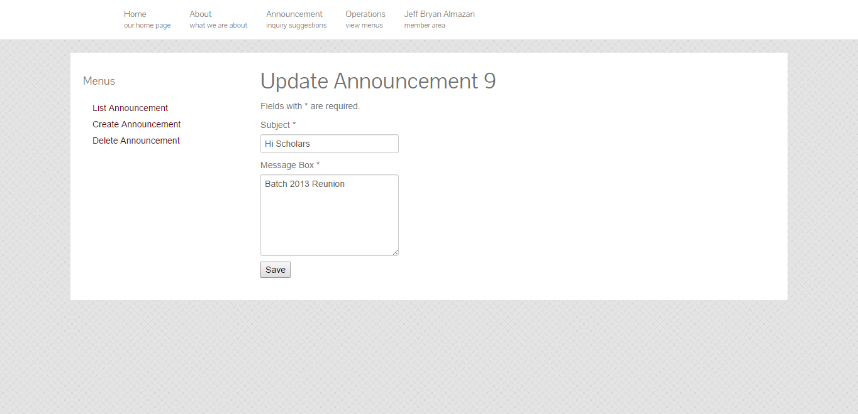

Create Scholar

Fill up the fields of the Following requirements in Profile:

* Lastname
* Firstname
* Middlename
* Sex
* Civil Status
* Religion
* Date of Birth
* Place of Birth
* Contact Number
* Email
* Click next

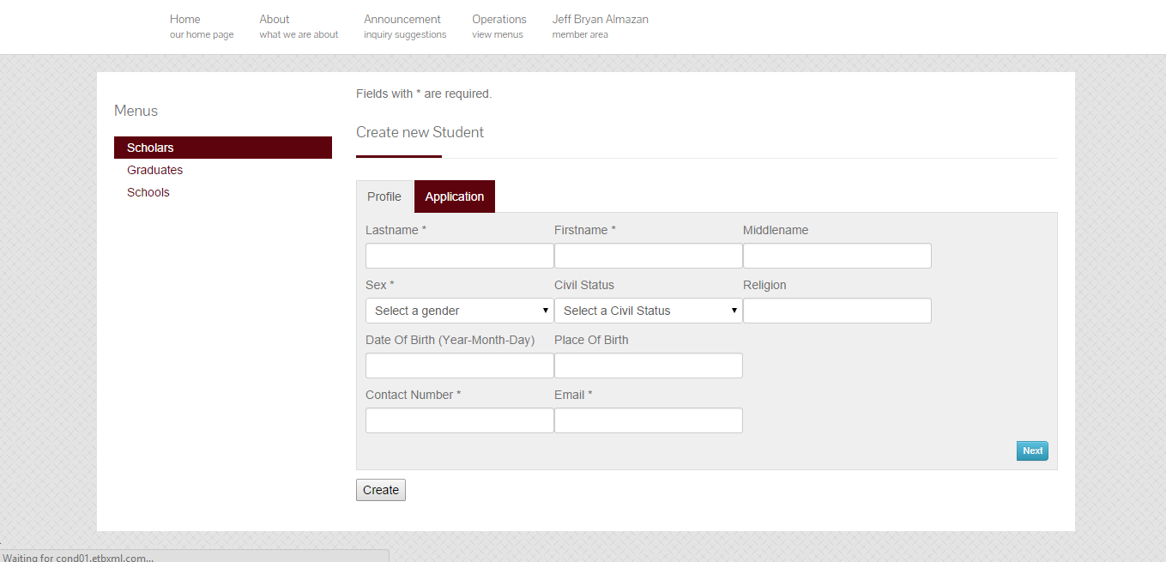

Fill up the fields of the Following requirements in Application:

* School
* Type of Application
* Course
* Duration
* Click create

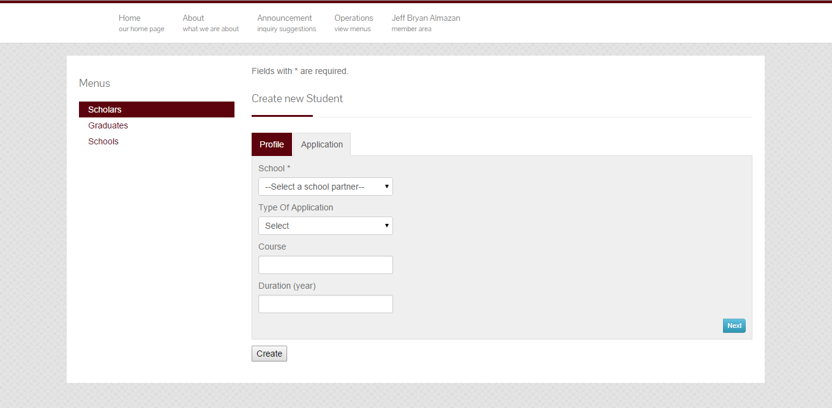

Edit Scholar

* Click any in the information’s
* Click check mark

Change role for scholars

* Click Student
* Click dropdown for roles
* Click check mark

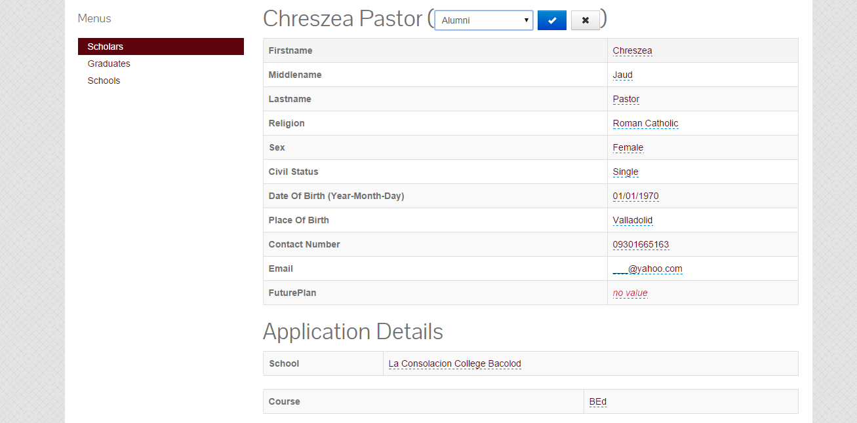

Update Scholar to Alumni

After you choose role for the scholar you have to

* Put year started and year ended of the Graduated scholar
* Input Honors if the student have honors
* Click Check mark

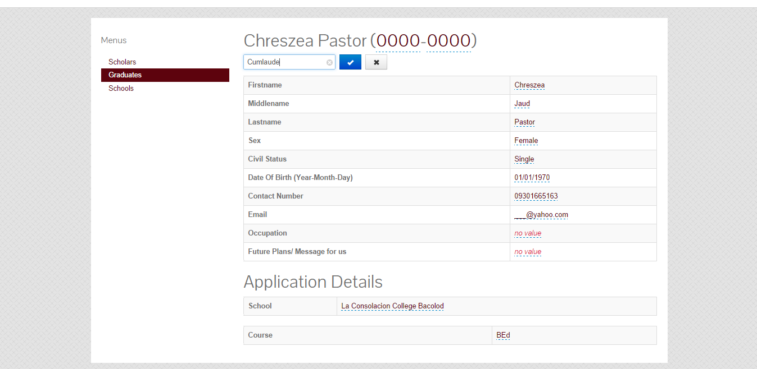

Create Alumni/Graduate

Fill up the fields of the Following requirements in Profile

* Lastname
* Firstname
* Middlename
* Sex
* Civil Status
* Religion
* Date of Birth
* Place of Birth
* Contact number
* Email
* Future plan
* School
* Course
* Honor
* Year started   
  Year Ended
* Occupation
* Click Create

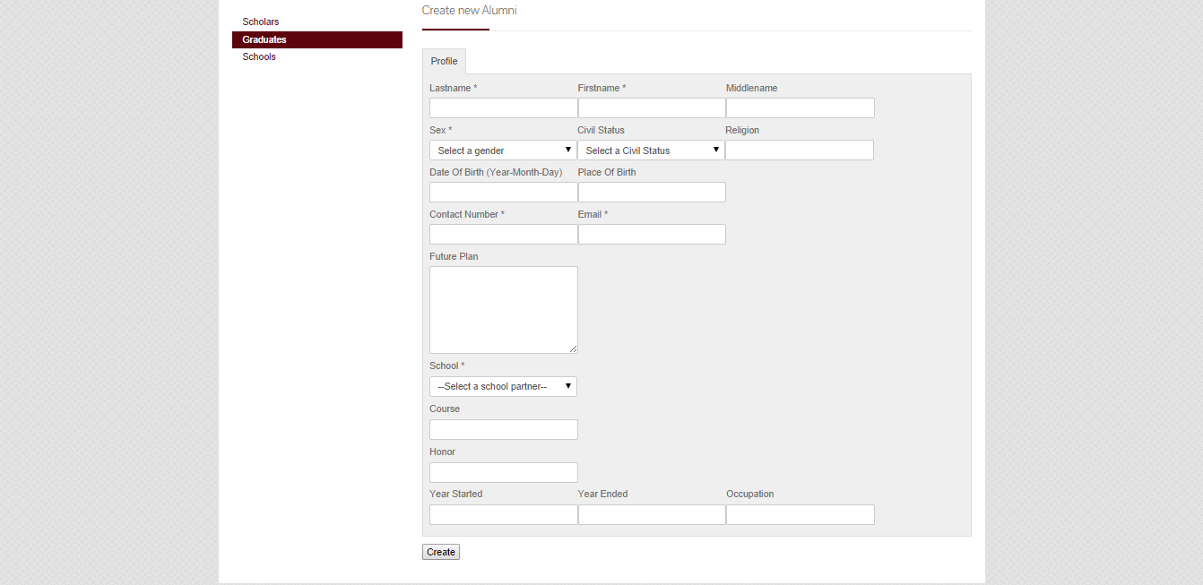

Update Alumni

* Click any of the information’s
* Click check mark

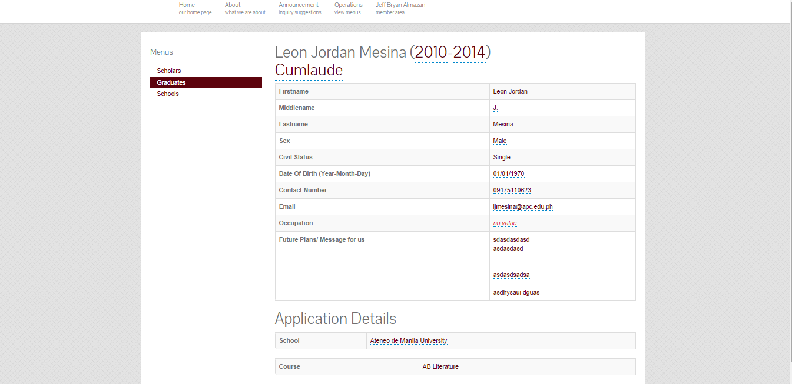

Create Schools

Fill up the fields of the Following requirements in Schools

* Name
* Address
* Contact No.
* Click Create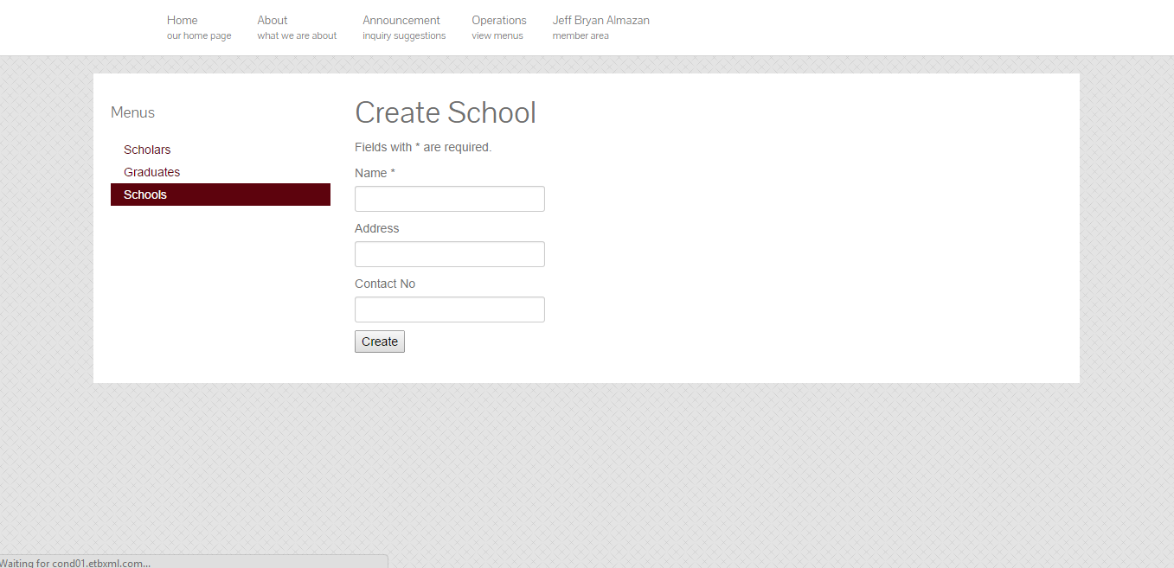

Update and Delete Schools

* Click Update to edit school or click delete to delete school

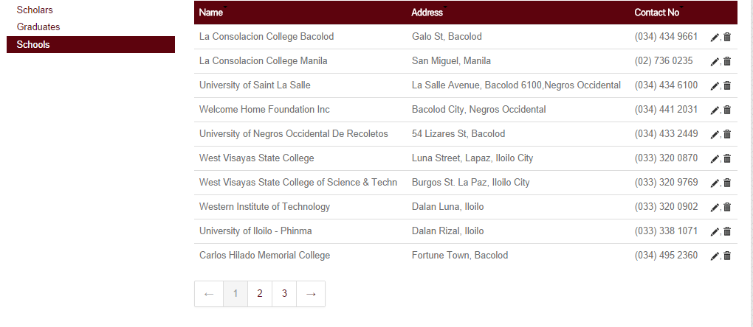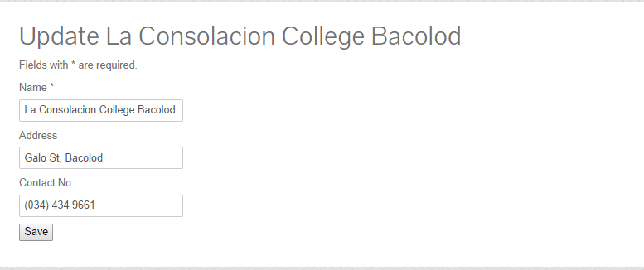

Alumni Log in

* Input Username and Password



Update Profile Alumni

* Click any of the information
* Click Check mark

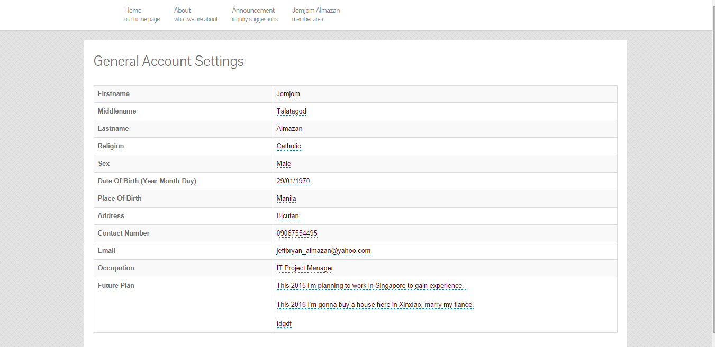

Alumni Change password

* Input Current Password
* Input New Password
* Input repeat new password
* Click Save

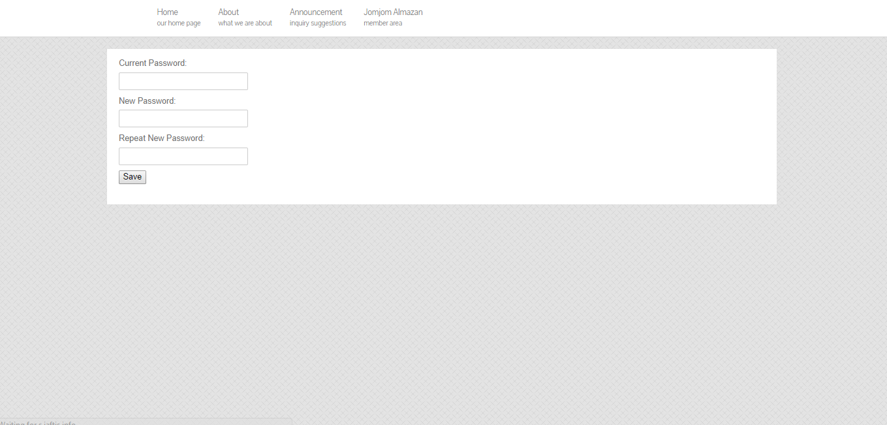

Alumni Announcement

* Alumni can only read announcement from the admin

